**Quarterly Report – Public Page**

**Date of Report:** 9th Quarterly Report - January 28, 2025

**Contract Number:** *693JK32210015POTA*

**Prepared for:** *DOT-PHMSA*

**Project Title:** *Dynamic Geohazard Risk and Decision Support Platform*

**Prepared by:**  *Boston Geospatial, Inc.*

**Contact Information:**  *Justin Oliveira,* [*justin@bostongeospatial.com*](mailto:justin@bostongeospatial.com)*, 321-720-3568*

**For quarterly period ending:** *December 31, 2024*

**1: Items Completed During this Quarterly Period:**

A detailed overview of the progress this past quarter is provided in the various sections below.

| ***Item #*** | ***Task #*** | ***Activity/Deliverable*** | ***Title*** |
| --- | --- | --- | --- |
| - | 0.1 | 9th Quarterly Status Report | Submit 9th quarterly report |
| 24 | 7.1 | Integration | API service integration and client management setup; ArcGIS tool ribbon development |
| 25 | 7.2 | Integration | Submit consolidated API documentation and ArcGIS ribbon user's manual |

**2: Items Not-Completed During this Quarterly Period:**

| ***Item #*** | ***Task #*** | ***Activity/Deliverable*** | ***Title*** |
| --- | --- | --- | --- |
| 26 | 8.1 | Backtesting | Backtesting of tool with TAP operators |
| 28 | 8.1 | Backtesting | Backtesting of tool with TAP operators |

**3: Project Financial Tracking During this Quarterly Period:**

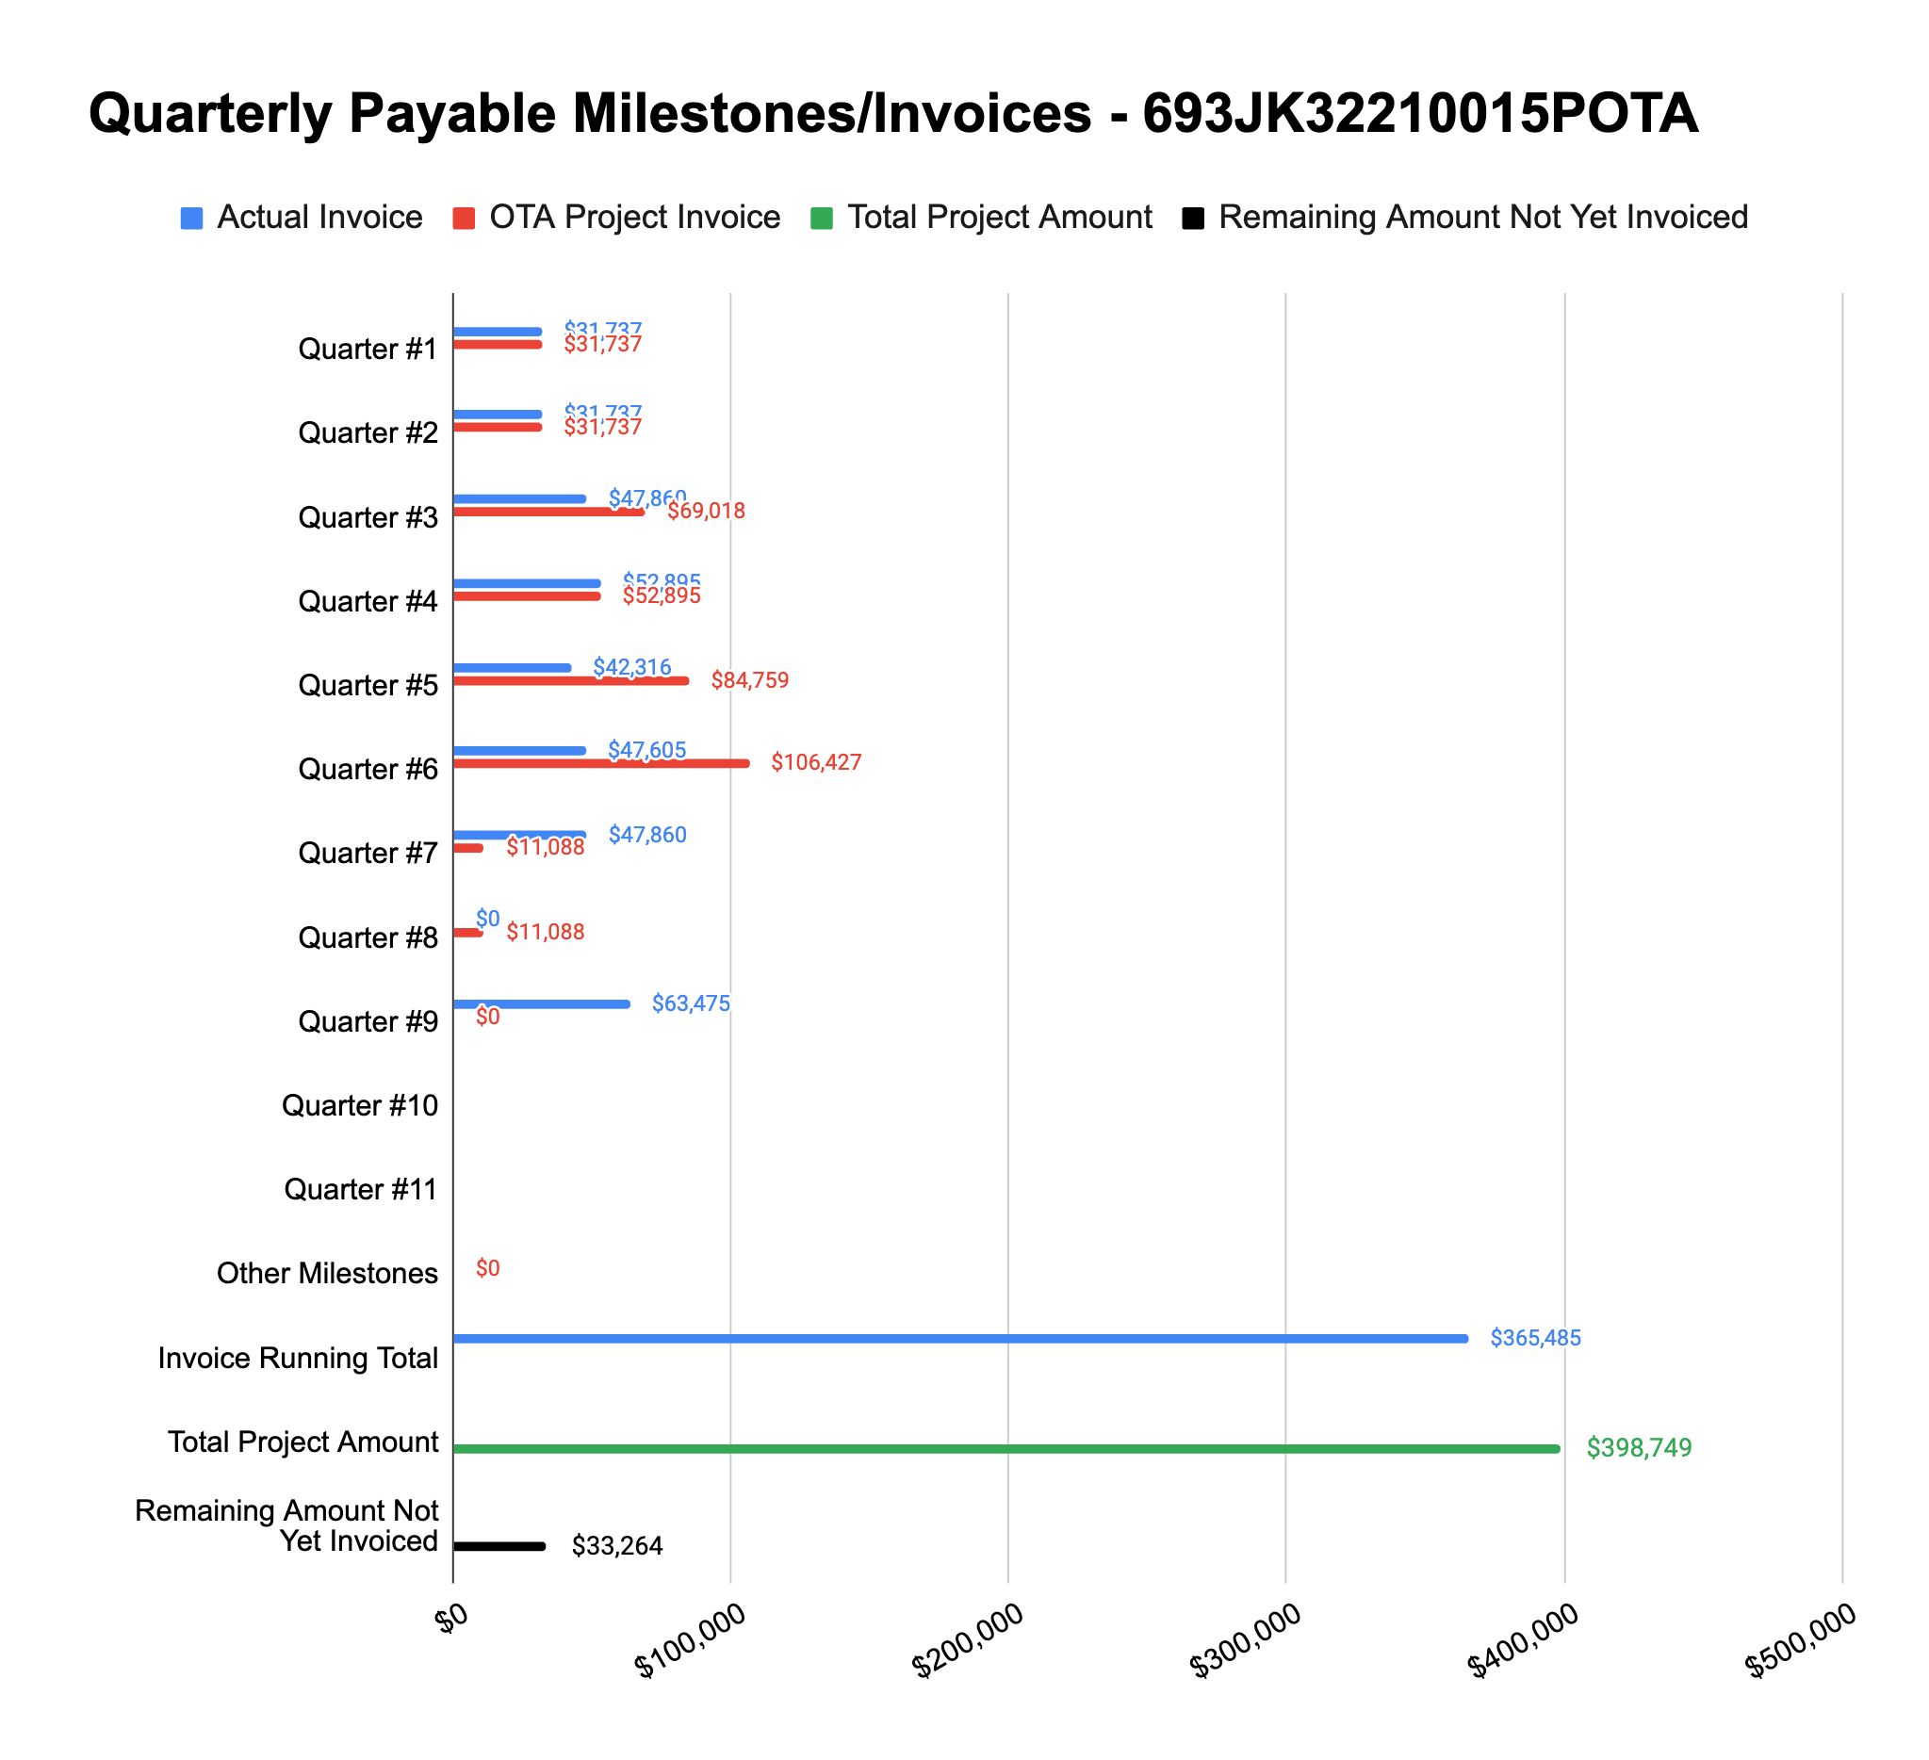

**4: Project Technical Status –**

**Item# 24 / Task# 7.1/ Integration / API service integration and client management setup; ArcGIS tool ribbon development**

Work on this task is now complete - we are now working with TAP operator data and fully in the backtesting stage now. As mentioned previously, we are submitting this revised Q9 report to document this progress formally.

**Item# 25 / Task# 7.2/ Integration / Submit consolidated API documentation and ArcGIS ribbon user's manual**

Work on this task is also now complete. A copy of the ArcGIS Tool User Manual v.1 and a revised version of the GIS Implementation Guideline Documentation (namely GIS Implementation Guideline Documentation v.2) have both been uploaded to PRIMIS.

**Item# 26 / Task# 8.1/ Integration / Backtesting of tool with TAP operators**

Our kickoff meetings with both operators have occurred and we are working with our POCs at the two operators we have on the TAP to set up a data sharing portal and exchange other needed information. The holidays slowed things down some given limited availability of the operators but we're now reengageing and picking up speed.

With operator #1, we have down-selected the area for the backtesting and are working to create a UPDM model from their PODS pipeline data model. To do this we have to write new code to load and translate their PODS model into the correct structure and fill in missing fields - this should be complete in roughly 10-14 days. Thereafter, and given that we have not yet processed any supplemental geohazard data for the area of focus, we will be performing an InSAR survey (where possible) as well as differential LiDAR analyses (using operator-provided LiDAR captures) for the remainder of January. We anticipate that in February we will then move towards running the backtesting scenarios and sharing the initial results with the operator.

With operator #2, we have discussed a couple locations of interest which have experienced geohazards ranging from sinkholes to landslides - the down select to the area of focus is slated to occur during our next tag up on January 15th. In parallel we are coordinating with the operator’s GIS department to facilitate data exchange. Given the time needed to ingest the operator’s data model and other activities, we anticipate backtesting with the operator to begin in February sometime.

We also have a small handful of meetings set up with other operators to discuss joining the TAP. If they join, backtesting with them will proceed efforts with the first two operators.

**Item# 28 / Task# 8.1/ Integration / Backtesting of tool with TAP operators**

Please refer to our comments in the Item 26 section above.

**Item# – / Task# 0.1/ 9th Quarterly Status Report / Submit 9th quarterly report**

Additional detail not necessary - this report constitutes the deliverable for Item# – / Task# 0.1.

**5: Project Schedule –**

Overall our project is on track given our updated project timeline. The backtesting with the first two operators should be done by the spring, and we will use the remaining time thereafter for additional TAP operators if they officially join the project.